**ST JOHN PAUL II COLLEGE GULU**

**GEOGRAPHY NOTES**

* **YOU ARE ENCOURAGED TO COPY THE NOTES IN YOUR NOTES BOOK SINCE THESE COLLEGE NOTES GIVEN TO YOU WILL BE WITHDRAWN AT THE END OF THE TERM**
* **KEEP THESE NOTES CLEAN WITHOUT UN NECESSARY WRITINGS**

**REGIONAL GEOGRAPHY OF CHINA**

**THE POPULATION OF CHINA**

China is the world’s most populous country with approximately 1.9 billion people, with a population growth rate of nearly 2% and her population represents 20% of the world’s population of 6.8 billion people. The country’s total fertility rate is 1.7 and consists of 56 ethnic groups which include the Han, Manchu, Zhuang, Puyi, Yi,Hui,Korean, Tibetan, Uygur,Mongols,Miaa.

The great majority of 69% of the population is between 15-64years. While 25% is of the age of 14 and below, 7% of the age of 65 and above. The life expectancy of china is estimated at 71.9 years i.e. 69.6years for males and 73.3years for females**.**

**A SKETCH MAP OF CHINA SHOWING POPULATION DISTRIBUTION.**

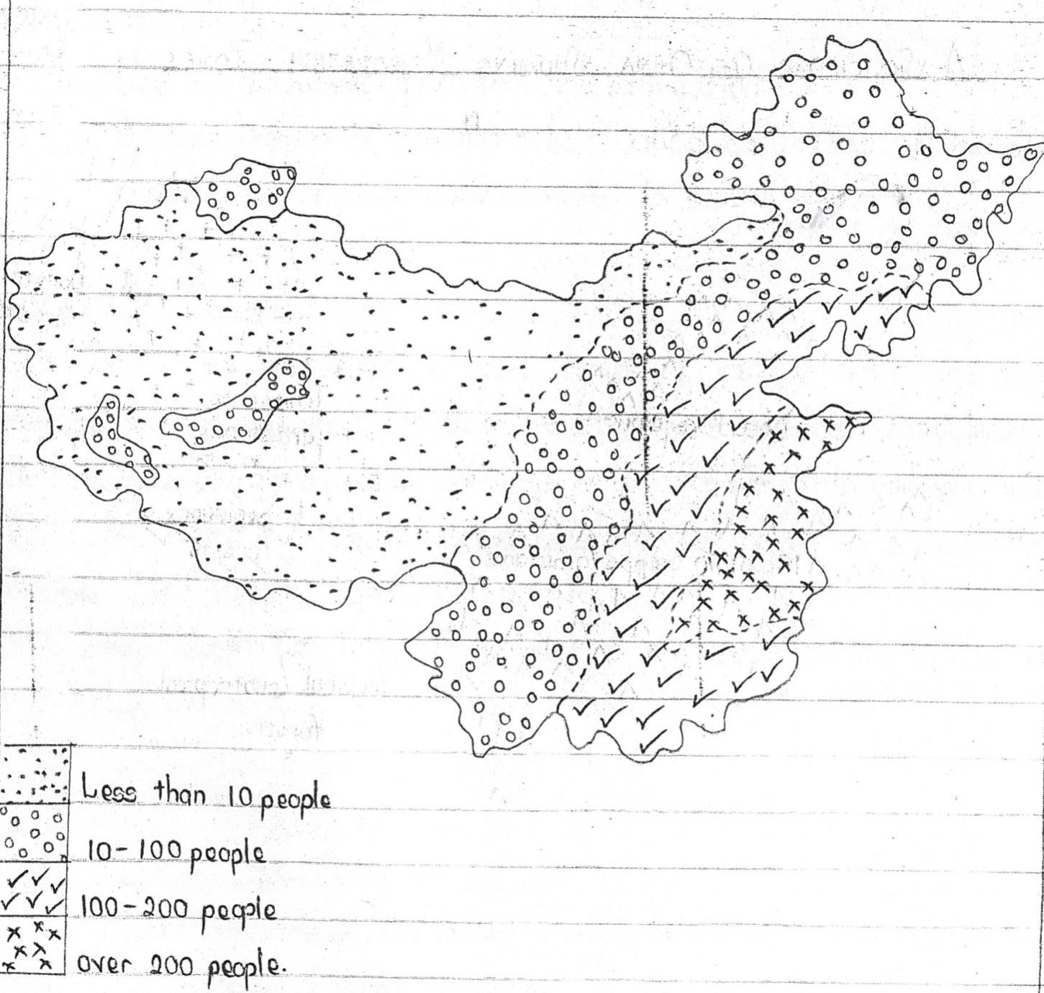

**FACTORS INFLUENCING POPULATION DISTRIBUTION IN CHINA.**

Population distribution in china is highly uneven where the high population concentration is in the eastern area with a density of over 400 persons per km.

Sparse population is found in the northern and western parts of the country where the density is less than 50 persons per km. several factors explain such a pattern of population and some of them include the following;

1. Presence of fertile alluvial soils along river valleys such as Sikiang and Yangtze and yellow river in the east which favor human settlements hence dense population in the east while thin infertile soils in the Himalayas and the desert sands in the west limit crop cultivation and livestock farming thus a low population.
2. Heavy rainfall and warm temperatures especially in the south and central parts of china at least high population while the very cold temperatures in the Tibetan highlands together with hot temperatures in the west limit population in the area.
3. The plains and lowlands especially in the central and eastern regions have attracted infrastructural development prompting dense settlement unlike the mountains west on the Himalayas with a steepness that limits population settlements.
4. The existing mineral potential of various areas stretching from Nanling to Xinfiang and the north –eastern region of Manchuria area attracting a dense population to enjoy mineral benefits unlike the less endowed west thus low population.
5. Eastern china is well- drained with numerous rivers and lakes which provide water for both domestic and industrial use and also useful for navigation which attracts a dense population compared to the west with poorly drained river valleys and water scarcity limiting population settlements.
6. The poor pastures in the west encouraged herding which leads to sparse populations in the west.
7. Urbanization with better social facilities especially in the coastal areas of Hongkong, shanghai, Cantan,Beijing (Peking) attract high densities of population compared to the rural areas in the west and north with low densities.
8. Presence of well-developed transport and common networks ranging from airports, waterways roads and railway systems has attracted dense populations in the east, central and northern parts unlike the less accessible areas in the west and south parts.
9. Industrial areas like Shangal, Beijing, Manchuria, Hongkong and Guanzhou have attracted dense population in search for employment and trade partnerships unlike the less industrialized areas of the west.
10. The positive government policy of starting up communes and redistributing the people led to dense populations in agricultural zones unlike places where agriculture was not possible i.e. the western areas.
11. Historical factors have also influenced population distribution in china. Early civilization stated along river valleys in the east creating a long history of dense settlements in such areas unlike western china where such histories are not traced.
12. Presence of social services such as education, health insurance, and banks recreation centers especially eastern china attracted large settlements unlike western china where such services are limited.
13. Presence of employment opportunities in mining areas, manufacturing industries and agriculture in eastern china accounts for the large population unlike the western part of china is limited in the same.
14. Racism in china where the easterners regard themselves as more superior than the Chinese in the interior. The easterners are more in number and cannot migrate to mix with the minority in the west.
15. Culturally, nomadic herders in western china encourage small population densities compared to the settled farmers in eastern china.

**AREAS OF SPARSE/LOW POPULATION IN CHINA.**

The areas known to have low population on china’s land include; Tibet, InnerMongolia, Qinghai, N.W, China, Yunnan region,Xinjiang etc.

**CONDITIONS FOR LOW POPULATION IN CHINA**.

* The climate conditions in the Tibet are cold and harsh, in the North West are arid and semi –arid conditions such as the Gobi Desert all of which limit settlement.
* The high altitude areas in the south such as the Tibet, Himalayas, and Kunlunshan mountains limit settlements since they are too cold for human life.
* A rugged relief in the Tibet, Yunnan region, inner magnolia limit not only settlement but also accessibility and infrastructural development
* Remoteness of the Yunnan, Tibet inner Mongalia, limit settlement since they are far from the coast and are poorly served by common lines.
* Presence of thin infertile soils limits agriculture hence discouraging settlements in such areas.
* Limited social amenities coupled with few urban centers that do not attract settlement.
* Limited productive economic activities like industry mining and tourism has limited settlement.
* Cultural factor for example the best form of land use is nomadic herding practiced by the Tibetans, Kazaks, Mongols and Kirgiz who rear goats, sheep, horses and camels and this partly explains the sparse population.
* Government policy of forest conservation/ nature conservation and limited infrastructural development discourages population settlement in such areas leading to sparse population.
* Political unrest/ insecurity discourage productive activities like trade, farming leading to sparse population such as the north western areas bordering Mongolia and Kazakhstan.
* Limited open surface water sources such as rivers and lakes for agricultural, domestic and industrial use has discouraged human settlement in such areas.

**ADVANTAGES OF LOW POPULATION**.

* It is easy to plan for a small population
* There is no pressure on the available resources e.g. land, education, health facilities and skulls.
* It allows for mechanized/extensive farming if other conditions allow. o There is no competition for employment since jobs available can be taken up by the few people.
* There are loss effects of food shortages since food can be grown enough to feed the small population.
* It gives room for environmental conservation since vacant pieces of land can be used by the small population.
* There are fewer effects of congestion and traffic jam.

**DISADVANTAGES/PROBLEMS**

* High costs of infrastructural development due to limited available economic activities.
* Underutilization of resources of the available resources since the existing unexploited ones are seemingly enough.
* There is low labor force supply to engage in profitable economic activities. o Low market potential for the goods and services produced since the buyers are few.
* There is a low tax base for the government we will be used to implement government programs.
* There is a tendency to preserve primitive cultural practices arising from less exposure to foreign civilization.

**SOLUTIONS TO THE POPULATION DENSITY IN CHINA.**

* Encouraging of migrations from high to low density areas
* Development of infrastructure and spreading projects in the low populated areas e.g. rural industrialization and electrification to attract a dense population.
* Extension of roads and railways to remote areas to increase their accessibility and encourage dense population.
* Setting up industries to create jobs for the people in the sparsely populated areas.
* Reversing the trend of desertification through tree planting and other projects.

**AREAS OF DENSE POPULATION IN CHINA.**

The areas that are known to have dense population on china’s land mass include the coastal region of china, the North China Plaine, Xijiangbasin, Sichuan basin, and the provinces of Fujlan, Jiangzou, Shandong, Guangdanand Anthui.

**CONDITIONS FOR THE DENSE POPULATION IN THESE REGIONS.**

 The warm ice – free conditions at the coast brought by the warm Kuro-Siwocurrent attracted dense settlements.

 The high level of industrial developments attracted people for employment opportunities and trade.

 The growth of urban centers on the eastern seaboard attracted many people because of the social amneties and provided.

 The rich allaviat and losses soils on the North China plains support agriculture hence attracting dense settlements.

 The efficient transport and common systems by water, air and land increases accessibility attracting people to such areas.

 Availability of various mineral resources stretching from Manchuria region to Shanghal area up to Nanting attracted people of work in the mines.

 Abundant freshwater sources such as rivers and lakes which attracted early dense settlements. Along these basins.

 The relatively flat landscape made it easy to settle on and contract infrastructure hence dense settlements.

* The density concentrated areas also produce conducive subtropical climate with warm conditions favoring settlement.
* The government policy of infrastructural development and creating of investment zones attract population leading to moderate to dense population such as in the urban areas of the east.
* Political stability for a long period such as most urban areas of the east encourages productive activities such as trade, farming leading to dense population since the security of property and life is assured.

**PROBLEMS FACED BY POPULATION IN DENSELY POPULATED AREAS**

* They have limited accommodation leading to the development of slums.
* There is congestion of people and vehicles (traffic jam) which leads to delays in delivery of goods and services.
* High levels of unemployment since the available jobs are not enough for the high population leading to idleness and high crime rates
* This is too much pressure on land and other available socio- economic infrastructure leading to depletion of natural resources.
* They suffer from food shortages leading to malnutrition and starvation.
* Flooding is experienced due to land degradation.
* There are unhealthy environmental and sanitation conditions experienced leading to high spread of diseases.
* There is a lot of devegetation of the areas settled in leading to environmental degradation and deformation.
* The government spends a lot in providing of the areas settled in leading to environmental degradation and deformation.
* The government spends a lot in providing the necessary social- economic services such as hospitals, roads, schools etc.
* High level of pollution arising from industrial productions to meet the demands of the big population.
* The government finds difficulty in planning and catering for the large population.
* High costs of living are experienced due to shortage of the necessary goods and services.

**SOLUTIONS TO THE ABOVE.**

* Adaptation of a population policy on family planning of one child per family policy.
* Modernizing agriculture to increase productivity and meet the food needs of the large population.
* Importation of food to supplement the domestic food reserves.
* Government policy of the green revolution aimed at increasing quality and quantity of food produced to ensure food security for the large population.
* Diversification of economy to provide alternative employment such as farming, industrialization and mining.
* Establishment of health centers to help treat diseases.
* Establishment of planned settlements to curb down slum development.
* Construction of sky scrapers to reduce on congestion and pressure on land.
* Encouraging outward migration from the densely populated areas to the sparsely populated areas.
* Use of fertisers to improve on the soil conditions in order to improve productivity.
* Putting in place education programs to teach about the dangers of high population.

**MODERATE/MEDIUM POPULATION**

The areas with moderate population on china’s land mass include, Gansu, Guangai, Hunnan, Ticin, Guizhar, Heilongjiang.

**CAUSES/FACTORS FOR A LARGE POPULATION SIZE IN CHINA.**

* There are improved medical facilities in china which have reduced the death rates of the country and have improved on the life expectancy leading to a large population.
* China had a high fertility rate which gave rise to a large population.
* High standards of living with improved sanitation and medical care services with minor rural urban disparities.
* There were delayed attempts in the adoption of family planning measures making many children to be produced.
* Early marriages among the Chinese led to long child bearing periods which increased the population.
* Availability of plenty of land to produce more food which was again supplemented by imported food.
* There are high rates of migration in search for employment and education which increase the population numbers in the country.
* There is a high rate of industrialization leading urbanization and job opportunities that large numbers of people.
* There is political stability in the country leading to increased life expectancy which encourages a large population.
* A formally supportive policy to have many children for security reasons increased the population of china.
* China has a large population leading to high growth rate since many children are born.
* There is urbanization leading to trade and commerce attracting many people.
* There is high life expectancy due to the improved medical services and the nutritional code of conduct by china which reduces the death rate and consequently leads to a high population.

**POPULATION PROBLEMS IN CHINA.**

* They are faced with a problem of overcrowding which leads to the encroachment on marginal lands.
* High demand for food necessities which necessitates importation of more foodstuffs leading to high costs of living.
* Unemployment of sections of the people leading to high crime rates in the country.
* There is evolution of poor low cost housing (slums) to accommodate the large population which is associated with low poor standards of living.
* The high population led to over cultivation of land in communes which resulted into decline in productivity leading to food shortage.
* There is a large dependent population in form of the young and elderly which affects their savings and investments of the country resulting elderly which affects their savings and investments of the country resulting into poverty.
* There are high rates of environmental pollution due to the poor discharge of domestic and industrial wastes, on land, air and water which results into health problem.
* There is traffic congestion leading to delays /delivery of goods and services as well as accidents.
* Congestion has led to poor sanitation and easy spread of diseases that threaten human rights.
* There is strain on the social services of the country due to high demands in the country

e.g.the roads, schools and hospitals.

* There is too much pressure on land for cultivation and settlements as well as limiting other economic activities. They are faced with high importation costs of food due to shortage of food.
* Rural urban migration is common leading to urban problems such as prostitution theft and drug abuse.

**MEASURES TAKEN TO SOLVE POPULATION PROBLEMS IN CHINA.** o Importation of food to supplement on food produced locally. o Modernization of the agricultural sector to increase food supply through mechanization, irrigation and use of improved seeds.

* Improvement of medical services to reduce spread of diseases and epidemics. o Construction of skyscrapers to solve problems of land shortage in urban areas.
* Caring out industrialization order to absorb the labor and reduce the rates of unemployment
* Caring out rural transformation programs to reduce rural-urban migration with its associated evils. o Diversification of the economy to include mining and industrialization and spread labor to reduce unemployment levels.
* Encouraging family planning to reduce rapid population growth. o Exportation of labor to other countries to reduce domestic unemployment o Reclamation of land to increase food production.
* Promotion of international trade by encouraging production for exports and getting more foreign exchange to cater for the large population. o There was introduction of a policy known as the one child family by the government where only one child by law is supposed to be produced in a family to reduce high population growth rates in the country.

**AGRICULTURE IN CHINA.**

China has of the most developed agricultural sectors in the world catering for the food needs of a high population. Agriculture in china accounts for 25% of the gdp(gross domestic product) and it employs about 60% of the country’s population. Food crops such as rice, corn, maize, sweet potatoes, millet, soya, beans and rubber are grown. The major agricultural zones of china can be summarized in the table below.

|  |  |  |
| --- | --- | --- |
|  | **Agricultural zone** | **Crops grown/animals kept.** |
| 1. | North east | Cereal, soya beans and sugar beets. |
| 2. | Inner Mongolia and along the great wall. | Wheat, rice, nomadic pastoralism |
| 3. | Yellow river, Hai and Huai rivers. | Wheat, cotton, groundnuts, fruits and animal husbandry. |
| 4. | The loess plateau | Fruit cultivation. |
| 5. | The middle and lower beaches of the Yangtze river. | Tobacco , silk, rice, cotton, oil crops, piggery and fish farming |
| 6. | South-western china | Tobacco, silk, tea, fruits, piggery and forestry, Corn, wheat, vegetables, poultry and fish farming. |
| 7. | Gansu and Xinjiang | Corn, rice, cotton, sugar beet, fruits and melons. |
| 8. | Qinghai- Tibet | Grain production, poultry, piggery and forestry. |

**FACTORS FAVORING AGRICULTURE IN CHINA.**

* Favorable climate brought by onshore monsoon winds and the sea breezes which creates heavy rainfall that favors crop cultivation.
* Abundant water supply from rivers such as Yangtze and Sikiang for irrigation.
* Presence of fertile alluvial soils deposited by rivers to support crop cultivation.
* Presence of a relatively flat land in the east of china which favors mechanization and irrigation.
* Presence of large sums of capital to buy farm input like fertilizers and machinery.
* Presence of improved transport and communication networks like roads, waterways, railways, connecting production areas to market centers.
* Availability of abundant cheap skilled and semiskilled labor required for planting and harvesting of the crops.
* Availability of a wide market provided by the large population in china which has attracted more investments into the agricultural sector.
* Presence of extensive land which has enabled massive production of both food crops and cash crops.
* The supportive government policy of the green revolution aimed at increasing food production in the country eradicate famine.
* The existence of communes and co- operatives which helped in mobilizing farmers, transporting and marketing of agricultural produce leading to improvement of agriculture.
* Presence of extensive grasslands that provide pasture for the livestock.
* Availability of large sums of capital.
* Extensive research geared towards improvements in both crop and animal husbandry which has consequently developed the agricultural sector.

**AGRICULTURAL COMMUNES IN CHINA.**

An agricultural commune is a system of farming where the farmers are organized into families to form production teams which in turn join to form production brigades.

**EXAMPLES OF COMMUNES IN CHINA**

1. Cham Shan commune
2. Red light commune
3. Yangtan commune
4. Honan/Henan commune
5. Ping Chaucommune
6. Danzhai commune
7. Fwan- ting commune
8. West china commune

**CHARACTERISTICS OF COMMUNES.**

* They have varying sizes depending on the available land
* Communes are organized/structured into families, production terms and brigades.
* They are state-owned and controlled
* Processing of agriculture produce is done on the communes
* The communes are collectively organized
* The population size has an influence on the level of activities and services a commune will have.
* The production, marketing and consumption patterns on the commune are centrally organized/organized by the state.
* Communes provide social services to members such as schools, health facilities, banks and roads.
* There is a lot of research carried out to increase production on the communes.
* Training of workers to use modern machines and methods is done on the communes.
* The small sized plots are allocated to individual farmers for the growing of vegetables and other land uses.
* Procurement and distribution of agro-based inputs are a responsibility of the state.

**BENEFITS /CONTRIBUTIONS OF COMMUNES TO THE DEVELOPMENT OF CHINA**.

1. Provision of food for the large population leading to self-sufficiency in food needs of the Chinese population.
2. Families have been provided with employment opportunities in form of farmers, managers hence earning them income used to improve their living standards.
3. Communes have led to effective utilization of would be idle resources such as land.
4. They are a source of raw materials to the agro-based industries hence promoting industrial development in china.
5. Communes have encouraged infrastructural resources through building and construction of canals, railways and roads even to marginal areas which were inaccessible.
6. A lot of foreign exchange is earned as a result of exportation surplus foods from the communes leading to development.
7. Communes are a source of government revenue through taxation which is used to develop infrastructure.
8. Communes have enabled easy access to credit facilities in a way of acquiring personal assets which has helped to improve on people’s standards of living.
9. Communes a source of income to farmers which has helped to improve on their living standards.
10. Communes have promoted urbanization in their zones such as Xinjiang with their associated benefits like improved medical care, recreation and education services.
11. Communes have encouraged research which helps in productive investments both in agriculture and other economic sectors of china.
12. They have encouraged international trade and relations between china and other countries hence widening the market potential for the agricultural products of the country.
13. They have encouraged international trade between china and other countries which fetches foreign exchange in china.
14. There is efficient use of labor for the would-be idle population ensuring meaningful employment and better standards of living.

**Disadvantages (negative effects) of communal farming in China**.

* + - 1. Lack of individual initiative on the part of the farmers, due to compulsory grouping, on a whole agricultural efficiency remained low especially in the early years. This resulted into collective responsibility and some people regarding the system as forced on them.
      2. The policy makers and implementers did not do proper feasibility studies in all areas for example some farms were put up in areas with poor drainage and soils. The system brought the regional quota system which involved forcing regions to grow crops not suitable for that particular region just for the sake of government interests.
      3. Resistance from some farmers about the amalgamation of land. For example landlords detested the new system of land ownership because it deprived them of their rights over land.
      4. The system encourages idleness among farmers since some farmers have shown little interest in collective work. Thus many of them are members by registration rather than by participation.
      5. In many cases low wages were paid to farmers hence the incomes very low which could not effectively inspire hard work among the farmers.
      6. The price of the crops initially was fixed by the government / state and not the market mechanism. Therefore often times the individual peasant farmers on communal farms could be exploited.
      7. High level of bureaucracy / Delayed decision making such as on what to grow, when, how and where are undertaken by central committees with many people to consult, and hence delayed or hindered.
      8. Increased output resulted into over production and hence fluctuation of prices and incomes of the farmers.
      9. Leads to monoculture problems since more or less the same crops are grown over a long period of time, leading to loss of soil fertility/ soil exhaustion.
      10. There are also problems of destruction of the environment under the system of communal farms, because the individual peasant farmers do not care about soil conservation measures and the environment in general since the farms are collectively owned.
      11. Communal farming has led to biased distribution of government assistance to the peasants. The progressive farmers who have resisted communal work have not been assisted by the government.

**PROBLEMS FACED BY AGRICULTURE COMMUNES IN CHINA.**

* In accessibility of some communes due to underdeveloped transport and communication network.
* Occurrence of floods especially during the heavy rains leading to destruction of crop land.
* Severe winter conditions which bring communal work to a standstill hence affecting production.
* Outbreak of pests and diseases which affect both crops and farmers hence interrupting the quality and quantity produced on the communes.
* Increased cost of production due to increased capital investments in agricultural inputs such as machinery.
* Bureaucratic tendencies especially in the operations which limits innovation and creativity in the communes.
* The communes meet resistance since they disrupt the traditional and social set up of human life.
* Poor management of the farms on communes resulting into low production.
* Soil exhaustion on the communes due to over use of the allocated land resulting into low crop yields.
* The hardworking members are discouraged to work since the profits are shared with the lazy ones.
* Poor disposal of wastes and use of chemicals on the communes which leads to pollution of land, air and water.
* Widespread corruption among the officials since procurement is done by the government which leads to losses.
* The people developed a hostile attitude towards the communes due to the harsh working environments and forceful labor.
* The farms do not have a freedom to choose what to be grown which discourages the interests of the farmers from being hardworking.
* Poor planning leading to misallocation of resources such as land and labor.
* Over production leading to price fluctuations that affect the incomes of farmers.

**MEASURES TAKEN TO SOLVE PROBLEMS FACING AGRICULTURAL COMMUNES IN CHINA.**

* Introduction of new crops with commercial value such as sugar beet, to increase income sources for the farmers in the communes
* Establishment of agro-based and other light industries to diversify the income sources of the farmers.
* Improving irrigation through the use of underground irrigation channels to encourage all year round production on the communes.
* Extension of credit facilities in form of bans to the farmers in order to improve their farming systems.
* Establishment of demonstration farms to train farmers on modern ways of crop cultivation and animal and animal rearing to improve production on the communes.
* Changes in the land tenure system are being effected by offering some tracts of land to private individual farmers to grow their own crops for sale.
* Application of fertilizers and manure is done to improve soil fertility.
* Spraying crops with pesticides and insecticides to control pests and diseases
* Enforcement of strict laws against corruption to ensure effective management of the communes.
* Construction of dykes to control flooding in the river valleys.
* Practicing terracing and contour ploughing on the steep slopes to avoid soil erosion.
* Improving on the working conditions of the communes to encourage more farmers and improve on their living standards.

**AGRICULTURE IN THE SIKIANG BASIN.**

River Sikiang(Pearl River) flows into the South China Sea with tributaries like Tongkiang, Youjang.

It is a great farming area in china with great potential of cultivable land and abundant fresh water for irrigation. The major types of farming, dairy and mixed farming.

**ASKETCH MAP SHOWING LOCATION OF THE SIKIANG BASIN.**

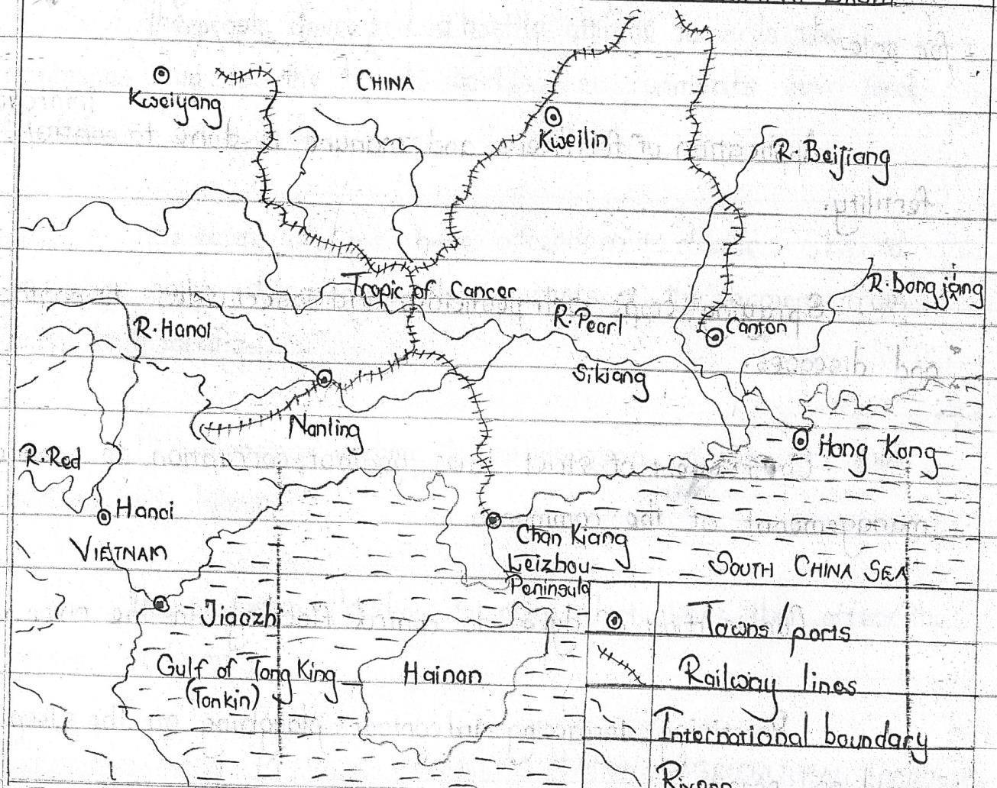

**FACTORS FAVOURING AGRICULTURE IN THE SIKIANG/PEARL RIVER BASIN.** o

* Presence of fertile alluvial soils which support the growth of a variety of crops and pastures.
* The warm sunny summer conditions ideal for the ripening of the crops especially the fruits.
* The 220 frost free days in the region which increase the period of the growing season hence promoting outdoor grazing.
* The heavy rainfall connected with the monsoon months from May to October which boosts growth of crops and pastures.
* Existence of rivers such as Sikiang that provide water for irrigation hence favoring all year- round cultivation. o Presence of a gently sloping landscape which encourages mechanization and irrigation farming.
* Land reclamation has expanded the area for agricultural activities in the Sikiang basin.
* The well- developed transport network of roads, railways and canals to transport network of roads, railways and canals to transport agricultural products to the market.
* Availability of appropriate technology such as the use of ploughs and canals which increase production. o Extensive research which has promoted production of improved varieties of crops in the region. o Availability of a wide market for the agricultural products provided by the large home population and abroad hence encouraging production.
* There is abundant cheap skilled and semiskilled labor to work on the farms. o Availability of large sums of capital to invest in agricultural activities through purchase machinery and payment of workers. o The favorable government policy geared towards expanding the agriculture sector in order to create self-sufficiency in the food needs of china.
* The development of agro based industries that consume agriculture raw materials which further encourage farming activities.

**EFFECTS OF AGRICULTURAL ACTIVITIES ON THE ENVIRONMENT IN THE PEARL RIVER BASIN.**

The effects of agricultural activities on the environment in the Sikiang river basin are both positive and negative as explained below.

**POSITIVE EFFECTS**.

 Foreign exchange is earned from the export of agricultural products which is used to develop other sectors.

 The farmers get income from the sale of their products which has improved on their living standards.

 Agriculture has encouraged food production from the farms ensuring food security in china, particularly the Pearl River basin.

* People have acquired employment opportunities from the agricultural farms such as transporters and farmers earning them income used to improve on their living standards.
* It has encouraged economic diversification through crop growing which offers alternative sources of domestic revenue to reduce over dependence.

 It has generated government revenue through taxes and license collected out of agricultural activities which is used for development.

 Agriculture has encouraged industrial development through the establishment of agro- based industries which employ a considerable number of people.

 Agricultural activities have promoted urbanization and development of towns such as Canton and Litang with their associated urban benefits.

 Agriculture has led to development of international relations between china and her trading partners such as USA and UK hence boasting international trade and inflow of foreign aid.

 It has led to the development of infrastructure, particularly roads, which improve on transportation of goods and services in the country.

 Agriculture has provided market for the various agricultural inputs such as pesticides, fertilizers and improved seeds.

**NEGATIVE EFFECTS.**

* It has increased soil erosion through the development of galleys which is a sign of environmental degradation.
* Agriculture leads to pollution of the environment due to the use of chemicals, pesticides and fertilizers as well as fumes from the agricultural industries.
* There is salination of the soils due to irrigation along the coastline and in the Sikiang river delta rendering the soils infertile.
* Soil exhaustion resulting from over use of the land resources.
* Siltation of the rivers as a result of cultivating along the river banks which leads to flooding.
* Destruction of the vegetation cover to create land for agriculture has led to the disappearance of vegetation in the Sikiang river areas.
* Agriculture has led to the spread of pests and disease vectors in the area through the different agriculture activities leading to low output.
* The heavy agricultural machinery leads to creation of hard population since it involves compaction of the soils.

**PROBLEMS FACED BY FARMERS IN THE SIKIANG BASIN.**

* Seasonal flooding which leads to destruction of agricultural land and displacement of people.
* Siltation which leads to flooding of canals hence reducing on the volume of water transported to the crop fields.
* Stagnation of water canals leading to the spread of water borne diseases such as bilharzia leading to death of people.
* Crop pests and diseases which reduce the quality and quantity of agricultural produce.
* High transport costs incurred in transportation of produce from the lower river valley to the market centers due to inaccessibility.
* Leaching of the soils is very high leading to infertile soils that cannot support crop growth.
* There is limited land for expansion/extensive farming hence reducing the crop yields.
* There is deposition of immature soils by the flood water of the Sikiang River which destroy the existing soil structure.
* Some river banks are very steep limiting crop cultivation and mechanization.
* There is use of elementary tools leading to low crop yields due to the inefficient technology.
* Limited cooperation amongst the people working in the communes which affects the volume of output.
* Price fluctuation due to over production which affects the incomes of the farmers especially when the prices decline.
* Perishability of the agricultural produces especially the fruits leading to post harvest losses

**MEASURES BEING TAKEN TO IMPROVE AGRICULTURE IN THE PEARL**

**REGION**

* Use of organic and artificial fertilizers to improve on the quality of oils and restore soil fertility.
* Land reclamation is carried out in swampy areas in order to create more land for farming.
* Spraying is done using pesticides and insecticides to control pests and disease vectors.
* Constant dredging of rivers is done to reduce silt.
* Construction of reservoirs to store water during the rainy season to be used during the rainy season to be used during the dry season.
* Resettlement of the displaced people by the floods.
* Construction of dykes to control floods.
* Giving credit facilities or soft loans and subsidies to farmers in order to acquire the necessary farm inputs.
* Construction of green to regulate the extreme hot condition
* Caring out crossbreeding to improve on the quality of the breed.
* Irrigation of large areas of land to encourage all year round cultivation.
* Regulating/recycling of the agricultural bi-products to make fertilizers and manure.
* Introduction of new improved varieties of crops through research to encourage diversification and increase on the quantity of produce.

**AGRICULTURE IN THE YELLOW RIVER BASIN**

This is another basin found in the north east of china.

The yellow river flows for about 4672km from its source in the Kunlunshan Mountains to its mouth in the gulf of Bohai. The river supports cultivation in form of collectivization with major crops including Garlic, Onions, Vegetables, and Tomatoes. Etc.

**FACTORS FAVORING AGRICULTURE IN THE YELLOW RIVER BASIN.**

* Fertile alluvial soils.
* Adequate fresh water for irrigation.
* Hot summer temperatures which favor ripening.
* Generally flat land which favors irrigation and mechanization
* Existence of large pieces of land for farming.
* Cheap abundant labor on the large population
* A wide ready market for the agricultural products.
* Efficient transport routes linking the farm to potential markets.
* Supportive government policy of encouraging the communes.
* Appropriate technology of using canals to irrigate farms.
* Large sums of capital to invest in agricultural activities.
* Intensive research for improved seed variety.
* Development of the green revolution in china which emphasizes the growth of rice and wheat favoring food crop production in the Huang ho basin.
* N.B. for benefits refer to those in the Sikiang basin.

**PROBLEMS FACED BY FARMS IN THE HUANG HO BASIN**.

* Soil erosion
* Flooding
* Water borne diseases
* Siltation of rivers.
* Limited land for expansion.

**STEPS TAKEN TO SOLVE PROBLEMS.**

* Construction of dykes to control flooding
* Construction of canals to divert excess river water into the farmland.
* Spraying with pesticides to control pests and diseases.
* Maximizing the available land using scientific methods of farming
* Acquisition of soft loans and subsides to gain more capital.

**SKETCH MAP SHOWING OF THE YELLOW RIVER BASIN.**

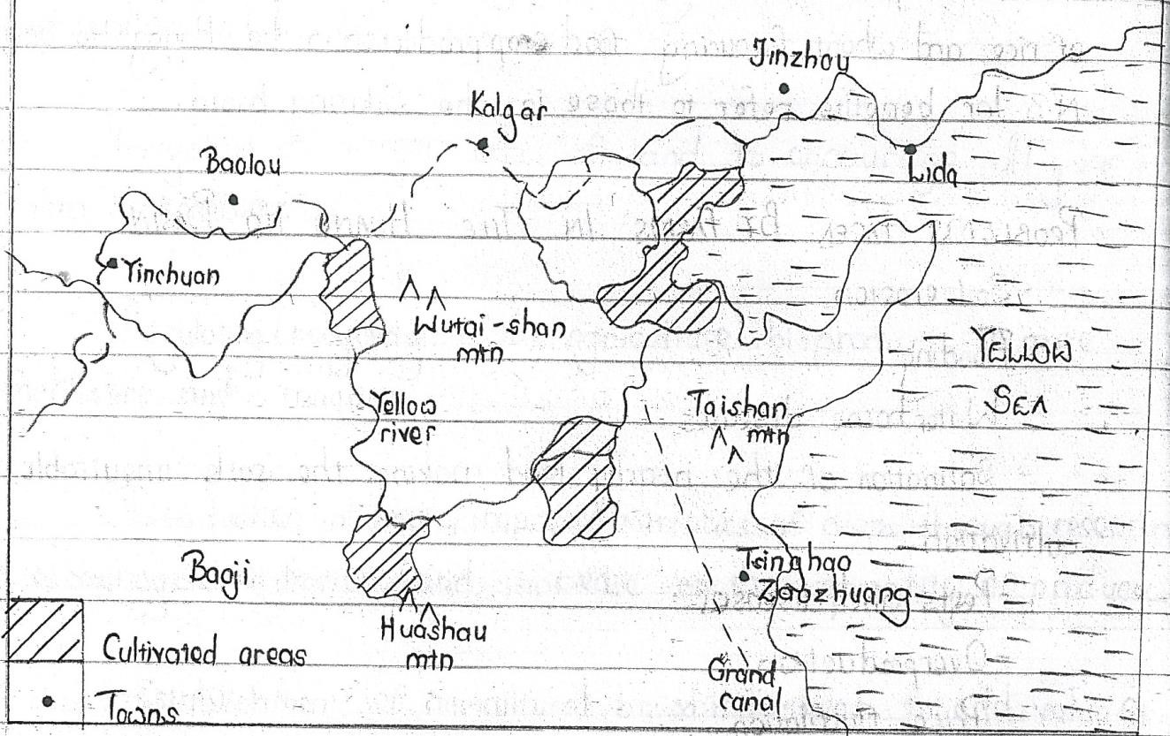

**IRRIGATION FARMING IN CHINA**

Irrigation farming refers to a practice of crop cultivation where water is artificially provided to the crop yields to boost crop growth during periods of low and unreliable rainfall. This type of farming is very essential in china and the country is known to have major irrigation systems with architectural designs. And some of the major irrigation schemes in the country include Dujiangyan, Quepiirrigation project, Zhengzhou irrigation canal.

**CHARACTERISTIC OF IRRIGATION FARMING**

* Artificial watering of the crops
* It is practiced in areas of low and unreliable rainfall which is unevenly distributed in a year.
* It is practiced in arid areas of hot temperatures and high evaporation rates.
* It is used mainly in extensive farming.
* It is highly mechanized
* It involves gravitational flow of water in canals
* It involves construction of canals aqueducts and aerial pipes.

**METHODS OF IRRIGATION.**

1. Perennial/gravity method. This method of irrigation involves digging of canals, ditches and channels linking farmland to the water flows naturally into the irrigation area.
2. Archimedean screw. Under this method, a metal pipe is fastened on a motor like stand with a perforated coil on top. The spreading of water in the cultivable land is determined by the acceleration pressure of the land.
3. Overhead lining: a perforated pipe is elevated higher than the basic crop height and well distribution irrigation land. When the water is released, it finds its way into the farmland through the outlets on the raised pipe.
4. Flood irrigation. Excess water in the lowlands is trapped or controlled in the farmland and slowly gets absorbed into the ground by filtration.
5. Drip irrigation. Under this method of irrigation, a variety of distribution pipelines that are evenly spread in the farmland are attached to the main supply pipe that drops water at slow rate. The method is common in green houses.

**FACTORS THAT HAVE FAVORED IRRIGATION FARMING IN CHINA.**

* Presence of extensive land that has enabled large scale farming with extension of farms especially in the west.
* Abundant water supply from rivers such as pearl, Yangtze and Huang supplementing on the unreliable rainfall.
* The existing desert climate in the north central and western parts with hot temperatures and unreliable rainfall that limit proper crop growth necessitating irrigation.
* Presence of relatively fertile soils of the losses type that are abundant in arid areas of china promoting irrigation to ensure production.
* The supportive government policy that aimed at putting to proper use the marginalized desert land in order to improve food productivity.
* The growing population of china that required more food for survival yet government expenses on imported food were rising hence resorting to irrigation farming
* A large population which offers cheap abundant labor to work on the irrigated farms.
* Presence of large sums of capital to build canals, ditches and aqueducts to facilitate irrigation.
* The growing levels of industrialization that require raw materials for massive production especially the agro-based industries necessitated irrigation farming.
* Appropriate technology used in farming e.g. the use of canals and drip irrigation which encouraged smooth running of the irrigated crop field.
* Introduction of the green revolution by the government of china.

This enhanced modern agricultural practices such as the growing of vegetable fruits and arable crops at specific temperatures with maximum supervision which encourages irrigation farming.

**IMPORTANCE OF IRRIGATION FARMING TO THE DEVELOPMENT OF CHINA.**

* Farmers earn income through working on irrigation farms which helps them to improve their living standards.
* The government earns a lot revenue through taxing farmers and irrigation machinery which is used to develop the country.
* China earns a lot of foreign exchange through exportation of irrigated crops to Britain and USA which is used for development.
* Infrastructural development ranging from canals roads and railways, liking farmlands to market centers.
* Through irrigation, there is increase in cultivable land hence ensuring all year –round production.
* Promotion of international relations between china and the countries importing her irrigation crops hence widening market for china’s products and allowing inflow of foreign aid.
* It has promoted industrial development especially agro-based industries that use farm produce hence creating more jobs to the people of china.
* There has been a reduction in the destruction effect of flood waters which is now used for irrigation.
* Irrigation farming has promoted urbanization along major canals and such towns include Beijing, Hangzhou, Soochou etc. with their advantages such as improved medical care and health.
* Irrigation farming has encouraged economic diversification of china hence reducing over dependence on mining and industrialization.

**NEGATIVE EFFECTS**.

* It attracts growth of weeds which compete with crops for soils nutrients leading to low crop yields.
* It causes leaching which results into low soil fertility.
* It brings about soil exhaustion due to perennial cultivation where one crop is grown on the same piece of land year after year.
* It brings about pollution of the environment through over use of fertilizers, pesticides and fungicides.
* It has led to development of towns and urban centers with their related problems such as slum development high crime rate and prostitution.
* Flood irrigation leads to growth of pests and disease vectors which spread malaria and river blindness to farmers.

**PROBLEMS FACING IRRIGATION FARMING IN CHINA**.

Siltation of the canals by deposited alluvium which limits flow of water to the crop fields.



Very hot temperatures which lead to high evaporation rates that drain the soils making them unsuitable for crop growth.

 Salination of the soils near the irrigated zones through capillarity making them less fertile and unproductive.

 Over use of fertilizers to ensure all-year –round production which end up polluting the soils through affecting the oil PH.

 Occasional flooding of the river banks during the heavy rainy seasons leading to destruction of some crop fields.

 High costs of production involved in dredging of silted canals, maintaining and repairing of cracked canals making irrigation farming very expensive.

Outbreak of pests and diseases which affect the quality and quantity of crops.



Limited land for agricultural expansion due to the ever increasing population which requires more land for settlement and infrastructural development.

 Pollution of irrigation water by industrial wastes and fertilizers leading to the wilting of crops.

 Over flooding which washes away the weak canal culverts hence distorting water transfer the crop yields.

**SOLUTIONS.**

* Dredging is carried out to reduce siltation.
* Use of particles and insect icicles to control pests and diseases.
* Treatment of industrial wastes before emission to reduce pollution.
* Hiring migrant workers during the busy periods to avoid labor shortage.
* Acquiring loans from the government construct and maintain. Irrigation canals.
* Land redamation of swamps and wastelands to create more land for irrigation farming.

**THE DUJIANGYAN IRRIGATION SYSTEM.**

This is an irrigation structure that was started in 256BC. During the worrying states period of china by the kingdom of gin.

It is located on R.Minjiang, west of Dujiangyan city in the Sichuan province.

Today, the DIS irrigation over 5300km of crop land and it is the world’s oldest surviving grand scale irrigation infrastructure comprising the Yuzuwater shade dyke, the Feishayan spill way and the Baopingkou water inlet.

**ASKETCHMAP SHOWING THE LOCATION OF THE DIS.**

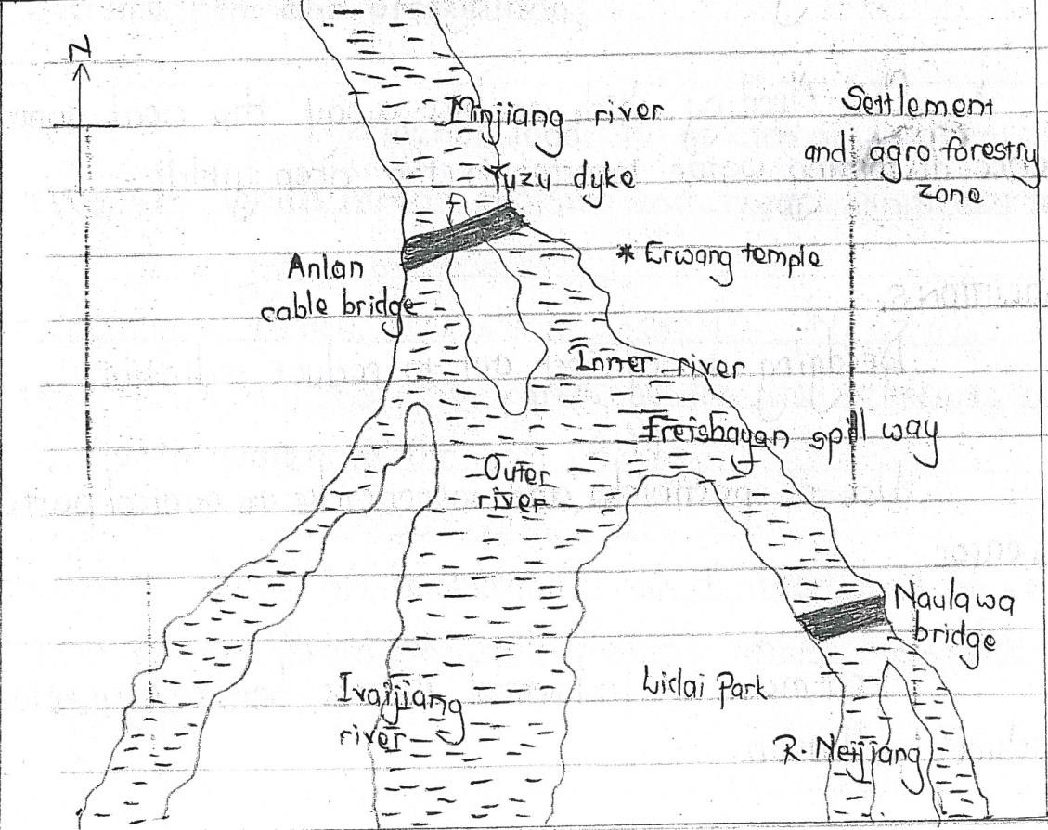

**OBJECTIVES OF THE DIS**

* To control flooding of the Sichuan province.
* To promote food security for the growing population of china.
* To put to use the spring melt water from Quingcheng Mountains and Mt.Yule.
* To ensure all year –round crop production.
* To effectively use the fertile soils of the Sichuan basin and the dry Chengdu region.
* To divert water to shipping people and agricultural production.
* To expand cultivable land in china.

N.B. for benefits, importance, problems and solutions to the problems facing irrigation farming in the DIS refer to the previous notes of irrigation farming in china.

FISHING IN CHINA

**FACTORS WHICH HAVE FAVOURED THE DEVELOPMENT OF THE FISHING INDUSTRY IN CHINA**

* + - 1. Presence of a wide and shallow continental shelf which allows sunlight to easily reach the seabed and this supports the growth of planktons which act as fish food.
      2. The meeting/mixing of the warm and cold ocean currents which also favours plankton growth (Kuroshio and Oyashio currents).
      3. Presence of a highly indented coastline which promotes fish breeding and promotes the development of fish landing ports.
      4. Presence of large forests to support fishing for example providing the required timber for construction of fishing vessels and construction of ports.
      5. Presence of a variety of valuable fish species and in large quantities such as salmon, sardines, mackerel, herrings, cod, and tuna leading to increased production.
      6. The cool temperate climate which ensures cool waters for the growth of abundant planktons and survival of various fish species.
      7. Presence of many rivers and streams which bring in mineral salts from inland for plankton growth and also provide breeding grounds for certain fish species.
      8. Presence of large fishing grounds particularly the Pacific Ocean containing many fish species and in large quantities like tuna, salmon and mackerel.
      9. Presence of a smooth ocean floor which promotes the use of modern fishing methods like trawling, and long lining.
      10. Availability of large sums of capital to invest in the fishing industry such as the purchase of modern vessels, the construction of ports.
      11. Large supply of skilled and unskilled labour to work in the fishing industry such as fish extraction, fish processing, transportation and marketing.
      12. Presence of a large market for fish and fish products both domestic and foreign which has encouraged the fishing industry.
      13. High level of technology employed in fishing such as the use of modern fishing methods (trawling, drifting) and modern preservation leading to high quality production.
      14. Intensive/ Continuous research in the fishing industry into breeding habits, feeding and maturation of various fish species (leading to high quality and quantity of production).
      15. Efficient/developed transport system involving developed ports, roads and railways; which promotes fishing, distribution and marketing of fish.
      16. Supportive / positive government policy towards the fishing industry such as encouraging investment by large companies and financing fisheries research.

**THE POSITIVE AND NEGATIVE EFFECTS OF THE FISHING INDUSTRY IN CHINA**

**POSITIVE EFFECTS**

* + - 1. Fishing has promoted industrial development by providing raw materials such as industries which make oil, fish meal, fertilizer, glue.
      2. Generation of employment opportunities in such as fish extraction, processing, transportation and marketing, to improve their standards of living.
      3. Generation of foreign exchange through the exportation of fish and fish products to various countries like France, Belgium, Sweden, and Spain.
      4. Fishing has promoted urbanization and port development such as shanghai, Guangzhou due to increased population.
      5. Development of other sectors especially agriculture by providing fertilizers.
      6. Provision of government revenue through taxation of the fishing companies, and workers’ incomes.
      7. Promotes international relations between China and other countries which import the fish and fish products such as Sweden, Portugal, and former USSR.
      8. Development of transport infrastructure such as roads and rail networks which transport fish products to the markets.
      9. Development of tourism due to large-scale fishing, use of modern technology such as trawler boats, and factory ships, which attract tourists and in turn generates foreign exchange.
      10. It has promoted diversification of the economy to reduce over depending on a few sectors such as forestry.

**NEGATIVE EFFECTS**

* + - 1. Results into over fishing and hence reduction in the fish stocks.
      2. Leads to pollution of the environment from the fish processing industries such as air and water pollution.
      3. Indiscriminate fishing also leads to a reduction in the fish stocks.
      4. Fishing leads to conflicts among countries such as Japanese catching large quantities near the coast of China.
      5. Attraction of labour from other activities such as crop farming and mining.
      6. Fishing is associated with accidents, leading to loss of life and property.
      7. Urban-related problems such as slum growth, high crime rate.
      8. Straining of the government budget due to financing of the fishing sector; hence limited investment in other sectors
      9. Depletion of forest resources such as during exploitation of timber for boat making.

**MEASURES HAVE BEEN TAKEN TO IMPROVE THE FISHING SECTOR IN CHINA**

* + - 1. The government has controlled of fishing activities in order to reduce over fishing and indiscriminate fishing.
      2. Strict regulations/ laws on fishing in particular seasons of the year to control over fishing.
      3. Treating and proper disposal of industrial wastes in order to control pollution of waters.
      4. Export of fish and fish products to other countries to solve the problem of small domestic market. Market research is also carried out.
      5. More factories that use fish as a raw material have been put up such as those producing animal feeds, glue, fertilizers, oil to increase the market for fish.
      6. Diversified fish sources such as by introducing fish farming to supplement the natural sources of fish.
      7. Increased mechanization to minimize the problem of shortage of labour.
      8. Signing international fishing agreements to solve conflicts over territorial waters. These agreements recognize fishing rights and grounds for each country.

CLIMATE IN CHINA

**CHARACTERISTICS OF THE CLIMATE OF KUNMING**

* + - 1. The area experiences warm mean annual temperature (12.50c)
      2. Large annual temperature range (190c)
      3. Very heavy rainfall is received (1781mm)
      4. There is a single maxima of rainfall (mono-modal rainfall)
      5. The area experiences very wet summers and moderate rainfall in winter (relatively dry).
      6. The wet season is relatively long and the dry season short.
      7. There are warm summers and cool winters
      8. The hottest month is July with 21.30c
      9. The coolest month is January
      10. The wettest month is May with 203mm (the heaviest rainfall)
      11. The driest month is January

**INFLUENCE OF CLIMATE ON AGRICULTURAL ACTIVITIES IN KUNMING**

**Positive**

During the wet summer season, farmers engage in activities like:

1. Planting due to adequate water for crop germination.
2. Weeding to remove the unwanted plants that compete with the crops.
3. Pruning to reduce excess branches from the crops for proper growth.
4. Spraying against pests and diseases that lower crop yields
5. Ripening of crops which favours harvesting.

During the relatively dry winter season, farmers engage in activities like:

1. Ploughing the land to prepare it for the planting season.
2. Clearing land to prepare it for the planting season.

**Negative**

During the wet summer season, climate leads to:

* 1. Rapid growth of weeds due to presence of surface water
  2. Flooding which leads to loss of soil fertility/ destroying farmlands
  3. Excessive soil erosion which leads to loss of soil fertility
  4. High spread of pests and diseases due to humid conditions

During the relatively dry winter season, climate leads to:

1. Shortage of pastures for animals and hence feeding indoors.
2. Planning farm activities for next planting season/ record updating

**CONDITIONS THAT HAVE INFLUENCED THE CLIMATE OF SHANGHAI**

1. Influence of the water bodies which contribute the heavy received in the area through evapo-transpiration process.
2. Influence of the ocean currents –warm kuroshio current and cold oyashio current
3. Low altitude leading to warm to hot temperatures in the area.
4. Latitudinal location/ the apparent movement of the overhead sun which results into heavy rainfall in the period of April to august when the over head sun is in the northern hemisphere and low rainfall in the period of oct to Feb. when the overhead sun is in the southern hemisphere.
5. Wind systems/ the prevailing onshore winds which lead to heavy rainfall received in the period of April to august.

**PROBLEMS FACED BY THE PEOPLE LIVING IN THE AREA AROUND SHANGHAI**

1. Rapid growth of weeds during the wet season which increases the cost of production.
2. Flooding which leads to loss of soil fertility/ destroying farmlands during the wet season
3. Excessive/severe soil erosion which leads to loss of soil fertility during the wet season/ due to heavy rainfall.
4. spread of pests and diseases due to humid conditions/ heavy rainfall
5. Rapid growth of weeds during the long wet season leading to increase in the costs of production.
6. High spread of pests and diseases during the wet season, which limits output.
7. Limited farm activities during the cool dry winters, which limits production.
8. Urban related problems such as slums, drug abuse due to increasing number of people.
9. Traffic congestion leading to unnecessary delays.
10. Pollution of the environment due various economic activities such as industry, trade and commerce, transport which reduces the quality of life

MINING IN CHINA

**FACTORS WHICH HAVE PROMOTED THE PRODUCTION OF IRON ORE**

1. Availability of large iron ore deposits/ reserves has attracted large-scale investment in the mining industry.
2. Some iron ore deposits are near the surface and thus easy to mine.
3. Large supply of energy such as petroleum, natural gas and hydro-electric power has also supported mineral exploitation and processing.
4. Well developed and cheap transport system provided by rivers, canals , railways to transport iron ore to industries and markets.
5. Large sums of capital to invest in mining such as mineral exploration, extraction, setting up processing plants.
6. Development in technology in the mining sector such as open-cast mining for exposed iron ore, adit method for deep ores. There is intensive research in mining technology such as the use of cranes, excavators etc to support mineral exploitation.
7. Presence of skilled labour employed in mining and mining –related industries such as geologists specializing in mineral exploration/survey, mining engineers, machine operators, managers
8. Presence of large market for minerals and mineral products in the industrial centres of China and also exported to Scandinavia, France, Italy and The Netherlands.
9. Political stability of the country, which also enabled the establishment and maintenance of mineral processing plants.
10. Positive /supportive government policy towards the mining sector such as investing in the mining, providing subsidies to mining companies.
11. High level of research in the mining sector which leads to the discovery of more mineral deposits, their quantity and quality. There is also research into the new uses of the iron ore.

**THE CONTRIBUTION OF IRON ORE TO THE DEVELOPMENT OF CHINA**

* + - 1. Generates government revenue due to taxation of various companies and workers
      2. Generates foreign exchange through export
      3. Promotes development of urban centres such as ……..
      4. Provision of employment to many people such as supervisors, transporters, hence better standards of living.
      5. Diversification of the economy by reducing over dependence on a few sectors such as agriculture.
      6. Promotes the development of infrastructure such as roads and railways which transport iron ore.
      7. Promotes international relations with other countries which are the markets of iron ore such as Germany, Holland

URBANIZATION AND PORT DEVELOPMENT

HONGKONG

**CONDITIONS THAT HAVE FAVOURED THE DEVELOPMENT OF HONGKONG ENTRPORT**

* + - 1. Presence of deep waters at the entreport enabling big/large ships to anchor easily.
      2. Presence of a well sheltered natural harbor that enables large vessels to anchor at the site (enables the port to handle all types of vessels).
      3. The low tidal range which allows easy shipping/anchoring of vessels to the coastline. Therefore, ships easily come and go at any time.
      4. Generally flat topography of the area encouraging the construction of port facilities such as buildings and transport systems.
      5. Ice-free conditions all year round thus enabling the use of the port throughout the year, leading to the growth and expansion.
      6. Strategic geographical location of the port at the east coast which gives it easy accessibility to foreign markets.
      7. Presence of a rich and productive hinterland comprising of areas like HongKong, China, Mongolia and parts of India which increases the cargo handled by the port.
      8. The development of many industries in the area such as shipbuilding, marine engineering, oil refining which has increased the volume of cargo handled by the port.
      9. High level of technology which has enabled the construction of the port facilities such as canals, and containerization at the port.
      10. Availability of large sums of capital to invest in the modernization of the port such as construction of canals.
      11. Political stability of the region, which has enabled the port to expand without any disturbance of war.
      12. Improvement in transport systems linking the port to the large hinterland for example roads and railways linking to the interior which has also increased the volume of cargo handled by the port.
      13. Supportive/ positive government policy for example the need to open up the region to easily access markets for the manufactured goods; and greatly financing the modernization of the port.
      14. Availability of skilled labour in the area to carry out modern construction and development of the port.

**IMPORTANCE OF HONGKONG ENTREPOT IN THE DEVELOPMENT OF CHINA**

1. The port has promoted trade between the interior and the rest of the world because it is a major entreport.
2. Promotion of industrial development due to handling raw materials and finished goods.
3. Promotion of urban development such as expansion of Hongkong city and other towns in the region
4. Promotion of mineral exploitation due to cheap water, and railway transport to industries and markets.
5. Promotion of tourism development since it is a tourist attraction, hence generating foreign exchange.
6. Provision of employment opportunities to many people such as engineers, hydrologists who monitor the water levels, hence improving the standards of living.
7. Generating of government revenue by taxing the shipping companies and workers’ incomes/ the revenue is used to develop various sectors such health, education.
8. Facilitation of international relationship/ cooperation between the countries of the interior and other parts of the world which promotes trade relations and economic integration/ international peace and unity.
9. Diversification of the economy in the countries by developing many sources of income / various activities such as mining, agriculture, service sectors.
10. Promotes the development of the agricultural sector due to large demand for food by the population in the region of the port.
11. Promoted the development of infrastructure like canals and railway lines linking various areas to the port.

**PROBLEMS WHICH RESULTED FROM THE DEVELOPMENT OF HONGKONG ENTREPOT**

* + - 1. There is congestion of vessels since it is one of the busiest ports in the world causing delays.
      2. Maintenance of the city is extremely expensive such as water supply, sewage disposal, law and order. This is due to overcrowding.
      3. Pollution of the environment especially due to toxic gases and wastes from industries such as oil refineries, petro-chemical industries, automobile industries.
      4. Narrowness and shallowness. There is still work to be done to expand the port and to deepen it in order to accommodate even larger vessels.
      5. Risks of fire hazards due to presence of oil tanks all over the port.
      6. Unemployment problems due to high rural urban migration and high population in the city. This leads to social evils like theft and robbery.
      7. Shortage of land for expansion of the port due to many activities carried out around the port.
      8. Population increase has led to inadequate housing resulting into slum growth.
      9. Overcrowding of people leading to easy spread of diseases and high crime rate.
      10. Risk of fire due to the presence of many oil tankers all over the port.

**SHANGHAI PORT AND CITY**

**Factors for the growth and development of Shanghai port/city**

1. Presence of a well sheltered and deep natural harbor leading to the Pacific Ocean. The harbor is well protected from strong water waves which favoured the construction of the port. This deep natural harbor makes Shanghai to handle all types of ocean-going vessels (barges and ships) and has therefore developed a modern port due to handling large cargo.
2. The low tidal range of less than 2 metres which allows easy shipping or anchoring of vessels to the Pacific coastline. Therefore ships easily enter and leave the port at any time.
3. Ice-free conditions throughout the year due to the conducive sub-tropical climate. This allows continued use of the port throughout the year and hence its modernization.
4. The topography of the area is relatively flat which allows easy construction of port facilities and accommodation facilities for the large population.
5. The Presence of a large and productive hinterland which covers the Shanghai city, eastern and northern china areas. Specifically these include Jiangsu, Henan, Nanjing, Beijing and the Manchuria region.
6. Rapid industrialization such as in Beijing and, Manchuria and Shanghai City led to increasing cargo handled at Shanghai port. This was because Shanghai is one of the easiest ports to trans-ship cargo to and from the region.
7. The strategic location of Shanghai port along the Pacific Ocean and on the mouth of navigable Yangtze River.
8. Relatively flat landscape of Shanghai which facilitated the construction and expansion of port facilities such as docking facilities, commercial buildings, and transport networks linking to the large hinterland.
9. Presence of a hard rock which provided a firm foundation for the construction of port facilities and the construction of tall buildings.
10. Historical factor—This led to a high population that favoured many activities like industry and trade, hence development into major urban centre and port.
11. Availability of adequate capital to develop the port and city. This has favoured the construction and development of port facilities.
12. Modern / High level of technology which led to improvement in modern port handling facilities—sky scrapers for accommodation, docking facilities, construction of the waterways, and reclamation of land to expand port.
13. Large supply of skilled labour in the area to carry out modern construction and development of the port. The large population of the region supplied the required labour.
14. The development of many industries at Shanghai which include oil refineries, iron and steel works, ship building, general engineering, automobile assembly lines, textiles, paper and printing, brewing, food processing. This has attracted many people to the port to look for employment and also increased the volume cargo handled by the port.
15. Political stability of the region which has enabled the port to expand without any ravages of war. The area has been stable for a long period of time and therefore many modern port handling facilities have been put up.
16. Modernization of transport systems linking the port to the large hinterland. For example, roads and railways linking to the interior of CHINA such as Nanjing, Henan and Beijing.
17. Supportive government policy for example the need to open up the interior —by easily accessing markets for the manufactured goods such as chemicals and sources of imported raw materials such as iron ore, tea, and cotton.

**PROBLEMS FACING SHANGHAI PORT AND CITY**

* 1. Pollution of the environment especially oil/petroleum related industries such as oil refineries, petro-chemical industries, automobile industries.
  2. There is congestion of vessels due to the increased number of vessel handled at the port and yet the handling facilities are limited.
  3. There is also congestion/ overcrowding of people in the city, and this leads to high crime rate among other problems. Due to this maintenance of the city is extremely expensive such as water supply, sewage disposal, law and order.
  4. Seasonal flooding, since the port is situated at the mouth of the Yangtze River which is prone to seasonal flooding. This in turn destroys life and property.
  5. Narrowness and shallowness. There is still work to be done to expand the port and to deepen it in order to accommodate even larger ocean-going vessels.
  6. Risks of fire hazards due to presence of oil tanks all over the port.
  7. Unemployment problems which is attributed to high levels of rural urban migrations and settlements due to port attraction facilities.
  8. Inadequate housing/ accommodation facilities resulting into the growth of slums—characterized by poor sanitation, drug abuse and easy spread of diseases.

**BEIJING CITY**

**Factors that have favoured the location of Beijing city**

* + - 1. Strategic location /Proximity to the East China Sea, Yellow Sea on the eastern coast for easy access to international trade routes.
      2. Gently sloping/ generally flat topography of the area encouraging the construction of urban facilities such as buildings and transport systems.
      3. Presence of a hard basement rock that has provided a strong foundation for construction of tall buildings and other urban infrastructure.
      4. Presence of a rich and productive hinterland which is agricultural and industrial which increases the volume of trade in the city.
      5. Availability of extensive land for the establishment of the large urban centre.
      6. Large supply of fresh water to support various urban activities such as domestic use and industry.
      7. Availability of various sources of power to support the urban activities such as HEP, oil and nuclear power.
      8. The development of many industries in the area such as engineering, iron and steel, machinery and textiles which has increased the population and volume of trade in the city.
      9. High level of technology which has enabled the construction of the urban facilities such as engineering technology in the construction of commercial buildings and the Grand canal.
      10. Availability of large sums of capital to invest in the modernization of the city such as construction of canals and roads.
      11. Political stability of the region, which has enabled the city to expand without any disturbance of war.
      12. Availability of modern transport systems linking the city to ports and to the large hinterland for example roads and railways which has also increased the volume of trade and industry in the city.
      13. Supportive/ positive government policy for example greatly financing the modernization of Beijing as the capital of China.
      14. Availability of skilled labour in the area to carry out modern construction and development of the city
      15. The large population in the city which provides large labour supply and market for the urban activities such as banking, education, industry.

**Functions of Beijing city** (Refer to those of New York City)

**Importance/ contribution of Beijing city & Problems facing Beijing city.** (Refer to those of New York City)

**Steps being taken to improve Beijing city**

* + - 1. Vertical expansion of the city by building sky scrapers to minimize the problems of limited space.
      2. Industrialists have advised to build elsewhere away from the concentrated area of Beijing.
      3. Treating industrial wastes before disposal into water to reduce pollution.
      4. Industrial fumes have been exposed high up in the atmosphere by very long chimneys.
      5. Proper housing plans drawn so that residential areas are far away from industrial zones to control pollution.
      6. Enforcing anti-pollution laws to reduce the effect of smog and diseases.
      7. Creating more green belts in the city to reduce the rate of pollution and improve the beauty of the city.
      8. Strengthening the police and urban authorities to fight against crime among citizens such as using heavy penalties/ punishments.
      9. Construction of more small scale/ cottage industries to create more jobs and hence reduce crime.
      10. Limiting the number of people entering Beijing City using strict laws and procedures to reduce unemployment and slum growth.
      11. Extending social amenities to the peri-urban areas and hence reduce overcrowding in the central business district.
      12. Constructing underground tunnels, by-passes and flyovers to reduce traffic congestion.
      13. Sensitization of the masses against racial discrimination by encouraging peaceful co-existence among different races.

**ECONOMIC ACTIVITIES WHICH ARE BEING CARRIED OUT IN THE YUNNAN PROVINCE OF CHINA**

* + - 1. Arable farming which involves crops like tea, maize, barley, oats, potatoes, wheat, beetroot, fruits.
      2. Forestry and lumbering which involves conserving and exploiting both natural and planted forests
      3. Animal rearing which involves beef and dairy cattle, and growing of fodder crops
      4. Industry which involves both heavy and light industries
      5. Trade and commerce which involves exchange of goods and services
      6. Transport
      7. Mining which involves exploiting minerals like copper, iron ore and limestone
      8. Tourism which involves the conservation natural resources, maintenance of cultural attractions and urban facilities

**FACTORS WHICH HAVE INFLUENCED THE ECONOMIC ACTIVITIES IDENTIFIED IN (B) ABOVE**

* + - 1. The relatively flat landscape which allows the cultivation and use of machines in farming, setting up and expanding industries.
      2. The sub-trpoical climate which allows a variety of crops to grow naturally.
      3. Presence of well drained fertile soils which have supported growing a variety of crops for long.
      4. Availability of large sums of capital to invest in arable farming , trade and commerce and industry
      5. Presence of a large market for output such as the large urban population. The country is also located in highly populated Asia and thus a ready foreign market available.
      6. The highly developed transport network such as water, railway, road to transport inputs and output.
      7. Well developed technology which has enabled farmers to increase production on the farms such as use of fertilizers, tractors on the farms, glass houses used for some crops.
      8. The favourable/positive government policy towards farming such as protecting and promoting local farmers, giving them subsidies.
      9. Presence of skilled labour to work in the agricultural sector such as applying fertilizers in farming, construction of industries.
      10. The formation of cooperatives which have improved the buying of inputs and the marketing of the output such as in farming.
      11. Developed/Intensive research carried out in farming, industry, tourism leading to the development of high quality production.

**MEASURES BEING TAKEN TO DEVELOP THE YUNNAN PROVINCE OF CHINA**

* + - 1. The government has come in to subsidize production such as the farm inputs for them to catch up with the increasing costs of production.
      2. Promoting organic farming which consumers are increasingly demanding although their price is a bit higher.
      3. Encouraging the use of fertilizers and organic farming to control soil exhaustion. Organic farming relies on crop rotation, manure, compost
      4. Spraying using of chemicals to control pests and diseases to increase farm production.
      5. Emphasis on mechanization to solve the problem of labour shortage in farm activities such as harvesting, sorting, packing.
      6. Many companies have resorted to importing raw materials for those which are relatively scarce.
      7. Emphasizing the production of high quality products. Still some industries have opened up plants in other parts of the world , targeting the market there.
      8. Using of migrant labour from other countries like India, South Korea.
      9. Emphasis on treating of industrial wastes to increase the quality of output although it increases the costs of production.
      10. Emphasis on production of high quality products to minimize competition.
      11. Improvement of transport infrastructure such as raods, railway and port facilities to ease transportation of raw materials and export of manufactured goods.
      12. Further diversification of economic activities to increase employment opportunities and incomes
      13. Maintaining political stability in the region to encourage more local and foreign investors.
      14. Controlling pollution using environmental standards and anti-pollution laws

**DEVELOPMENT OF RIVER BASINS IN CHINA**

**Steps taken by China ton develop the Si-kiang river basin**

* + - 1. Construction of numerous canals to help control the flow of waters for use during irrigation
      2. Establishment of various dams to provide hydroelectric power
      3. Development of strong embankments and barrages to control periodic floods
      4. Construction of strong dykes to cut off the sea incursions
      5. Building of several bridges and culverts to enable movement of traffic
      6. Construction of modern roads and railways to connect the river basin to the rest of China
      7. Constant dredging of sections of the river to allow the fast flow of river Si-kiang and its tributaries

**Contribution of the Si-kiang river basin to the development of China**

1. The fertile soils in the region have attracted settlement of many people hence promoting trade and commerce.
2. Provision of hydroelectricity for industrial and domestic use.
3. Perennial irrigation is now possible leading to the growth of food and cash crops throughout the year/ increased food supply.
4. Improvement in navigation on the river hence facilitating easy movement.
5. Promotion of industrial development due to many raw materials provided by the various activities and HEP hence increasing employment.
6. Promotion of urban development such as expansion of Hong Kong, Canton, Litang; with related advantages such as trade and commerce, employment.
7. Promotion of tourism development since it is a tourist attraction, hence generating foreign exchange.
8. Provision of employment opportunities to many people such as engineers, hydrologists, farmers, industrial workers hence improving the standards of living.
9. Generating of government revenue by taxing the shipping companies and workers’ incomes/ the revenue is used to develop various sectors such health, education.
10. Diversification of the economy by developing many sources of income / various activities such as mining, agriculture, service sectors.
11. Promoted the development of infrastructure like canals and railway lines linking to various areas, making transport easy.
12. The fishing activities on the river have increased people’s incomes.

**Environmental problems resulting from the development of the Si-kiang river basin**

* + - 1. Siltation of rivers which results into constant dredging which is expensive.
      2. Loss of fertile soils from the flood waters which reduces soil fertility, hence need to apply artificial fertilizers.
      3. Maintenance of the urban centers is extremely expensive such as water supply, sewage disposal, law and order. This is due to overcrowding.
      4. Pollution of the environment especially due to toxic gases and wastes from industries, hence spread of diseases.
      5. The growth of urban centers is associated with many problems such as slum growth, prostitution and high crime rate.
      6. Unemployment problems due to high rural urban migration and high population in the region. This leads to social evils like theft and robbery.
      7. Shortage of land/ Overcrowding of people leading to poor sanitation and easy spread of diseases.
      8. Prevalence of water borne diseases
      9. Floods are common in the region leading to loss of life and property.